HIGH PERFORMANCE SRAM DESIGN FOR ENERGY EFFICIENT SYSTEMS

S13APROJ2 – PROJECT WORK (PHASE – II)

Submitted in partial fulfillment of the requirements for the award of Bachelor of Engineering degree in Electronics and Communication Engineering

by

N UMESH SURYA KIRAN (Reg No. 42130311)

VADDI UGANDHAR (Reg No. 42130516)



DEPARTMENT OF ELECTRONICS AND COMMUNICATION ENGINEERING

SCHOOL OF ELECTRICAL AND ELECTRONICS

SATHYABAMA
INSTITUTE OF SCIENCE AND TECHNOLOGY

(DEEMED TO BE UNIVERSITY)

CATEGORY - 1 UNIVERSITY BY UGC
Accredited with Grade “A++” by NAAC | Approved by AICTE
JEPPIAAR NAGAR, RAJIV GANDHI SALAI, CHENNAI - 600 119

APRIL – 2026

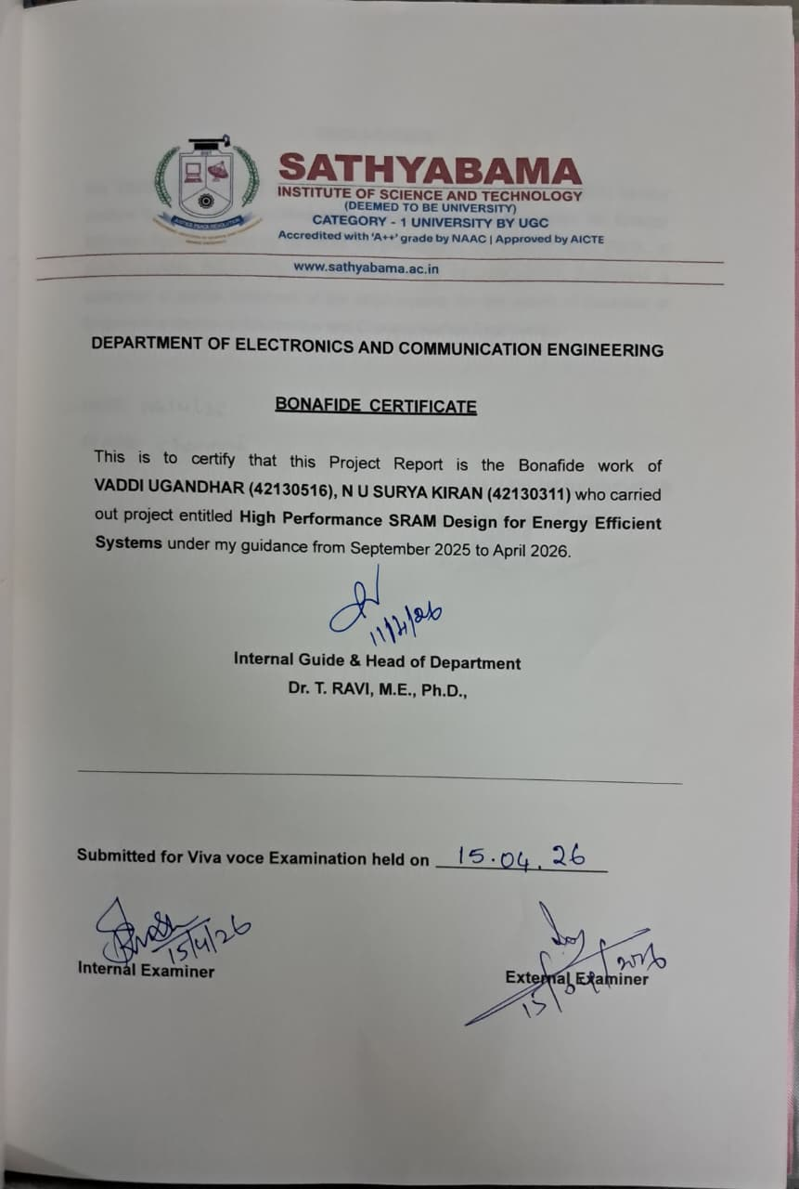

DECLARATION

We N UMESH SURYA KIRAN (42130311), VADDI UGANDHAR (42130516) hereby declare that the project entitled High Performance SRAM Design for Energy Efficient Systems done by us under the guidance of Dr. T. RAVI, M.E., Ph.D., at SATHYABAMA INSTITUTE OF SCIENCE AND TECHNOLOGY, CHENNAI is submitted in partial fulfillment of the requirements for the award of Bachelor of Engineering degree in Electronics and Communication Engineering.

DATE:
PLACE:
SIGNATURE OF CANDIDATES
1.
2.

ACKNOWLEDGEMENT

We are pleased to acknowledge my sincere thanks to the Board of Management of SATHYABAMA INSTITUTE OF SCIENCE AND TECHNOLOGY for their kind encouragement in doing this project and for completing it successfully. We are grateful to them.

We convey our thanks to Dr.T.RAVI M.E., Ph.D., Head of the Department, Department of Electronics and Communication Engineering for providing me the necessary support and details at the right time during the progressive reviews.

We would like to express my sincere and deep sense of gratitude to my Project Guide Dr.T.RAVI M.E., Ph.D., for his valuable guidance, suggestions and constant encouragement that paved way for the successful completion of my project work.

We wish to express our thanks to all Teaching and Non-Teaching staff members of the Department of Electronics and Communication Engineering who were helpful in many ways for the completion of the project.

ABSTRACT
Static Random Access Memory (SRAM) plays a critical role in modern integrated circuits, particularly in applications requiring high-speed and low-power operation such as Internet-of-Things (IoT) devices, portable electronics, and edge computing systems. With the increasing demand for energy-efficient designs, aggressive supply voltage scaling has become a widely adopted technique to reduce power consumption. However, voltage scaling significantly impacts SRAM performance by degrading noise margins, increasing susceptibility to process variations, and reducing reliability during read and write operations. Conventional SRAM designs face a fundamental trade-off between stability, power consumption, and area, making it challenging to achieve optimal performance under low-voltage conditions. In this work, a custom optimized 6T SRAM cell is proposed to address these challenges through intrinsic circuit-level optimization. The design focuses on improving read stability, write ability, and reducing leakage power by carefully optimizing transistor sizing and balancing the strengths of pull-up, pull-down, and access transistors. Unlike conventional approaches that rely on assist techniques or additional circuitry, the proposed design enhances performance within the standard 6T structure, thereby maintaining area efficiency and simplicity. The proposed 6T Architecture cell is designed and simulated using Cadence Virtuoso and evaluated under low-voltage operating conditions. Key performance parameters such as power consumption, read delay, write delay, and static noise margin (SNM) are analyzed and compared with an existing 7T SRAM design. Simulation results demonstrate that the proposed design achieves significant reduction in power consumption and leakage current while maintaining comparable read performance and improved write speed. The optimized design also exhibits sufficient noise margin, ensuring reliable operation under reduced supply voltage conditions.

TABLE OF CONTENTS

Chapter No | Description | Page No
 | ABSTRACT | v
 | LIST OF FIGURES | viii
 | LIST OF TABLES | ix
1 | INTRODUCTION | 1
2 | LITERATURE SURVEY | 6
3 | EXISTING METHODOLOGY  3.1 7T SRAM Architecture  3.2 Scope  3.3 Requirement Analysis  3.3.1 Functional Requirements  3.3.2 Performance Requirements  3.3.3 Area and Integration Requirements  3.3.4 Tool and System Requirements  3.4 Design Specifications  3.5 Constrains and Assumptions  3.6 Risk Analysis | 18  19  19  21  21  21  21  22  22  23  24
4 | PROPOSED LOW-POWER OPTIMIZED 6T SRAM ARCHITECTURE AND IMPLEMENTATION  4.1 Proposed Architecture  4.2 Transistor – Level Design and Optimization  4.3 Operation of proposed SRAM Cell  4.3.1 Hold Operation  4.3.2 Read Operation  4.3.3 Write Operation  4.4 SRAM Macro Architecture and Integration  4.4.1 Memory Array Organization  4.4.2 Row Decoder and Wordline Driver  4.4.3 Bitline Architecture  4.5 Implementation using Cadance Virtuoso  4.6 Testing and Validation plan  4.7 Result and Discussion  4.7.1 Transient Analysis and Functional Verification  4.7.2 Static Noice Margin (SNM) Analysis  4.7.3 Read Delay Analysis  4.7.4 Write Delay Analysis  4.7.5 Power Consumption Analysis  4.7.6 Energy Per Operation Analysis  4.7.7 Overall Performance Summary | 26  26  28  28  28  29  29  30  30  31  32  33  34  35  35  37  38  39  39  41  41
5 | CONCLUSION | 43
 | REFERENCES | 44
 | ANNEXURES | 47

LIST OF FIGURES

Figure No | Description | Page No
1.1 | Typical SRAM Cell Structure | 2
1.2 | Butterfly Curve for SNM Measurement | 3
3.1 | Existing 128×64 SRAM macro with 7T SRAM cell | 23
4.1 | Conventional 6T SRAM Cell Architecture | 27
4.2 | Read & write Operation Waveform of the Proposed 6T SRAM Cell | 29
4.3 | SRAM Macro Architecture Block Diagram | 30
4.4 | 4-Bit Addressed SRAM Array Organization | 31
4.5 | Wordline Driver Circuit | 31
4.6 | Decoder Circuit | 32
4.7 | Control and Timing Signal Sequence | 33
4.8 | Cadence Virtuoso Schematic of the 6T SRAM Cell | 34
4.9 | Transient Analysis – 6T SRAM | 35
4.10 | Transient Analysis – 7T SRAM | 36
4.11 | 6T SRAM Macro Output Waveforms | 36
4.12 | 7T SRAM Macro Output Waveforms | 37
4.13 | DC Analysis – 6T SRAM | 37
4.14 | DC Analysis – 7T SRAM | 38
4.15 | Power Analysis – 6T SRAM | 39
4.16 | Power Analysis – 7T SRAM | 40
4.17 | Power Analysis – 6T Architecture | 40
4.18 | Power Analysis – 7T Architecture | 40

LIST OF TABLES

Table No | Description | Page No
4.1 | Static Noise Margin Comparison | 38
4.2 | Read Delay Comparison | 38
4.3 | Write Delay Comparison | 39
4.4 | Power Comparison | 41
4.5 | Energy Comparison | 41
4.6 | Performance Comparison of 6T and 7T Architecture | 42

